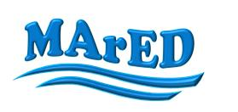
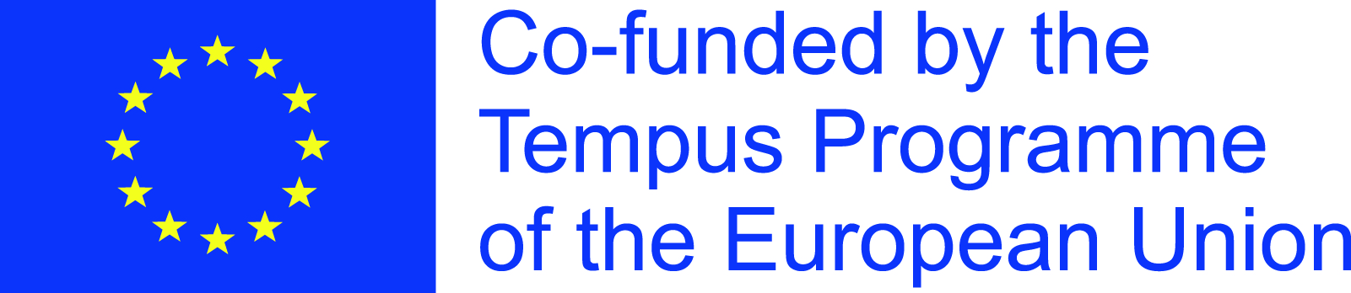

Modernizing and harmonizing maritime education in Montenegro and Albania - MArED

Management Meeting 4
Agenda
17th – 18th November 2016

Day I

09:30 – 10:00 Registration of the participants

10:00 – 10:05 Opening of the Meeting: introductory speech of the Coordinator

10:05 – 11:30 General overview of the realized project activities: presentation of the PC academic institutions
- University of Montenegro, UoM
- University “Ismail Qemali” of Vlora, UV
- Shkodra University “Luigj Guraquki”, UNISHK

11:30 – 11:45 Coffee break

11:45 – 13:30 General overview of the realized project activities: presentation of the PC industrial representatives
- Ministry of Education, MoE
- Crnogorska plovidba A.D. Kotor, CGPL
- Montenegrin Association of New Technologies, MANT
- Institute for Transportation doo, INTRA
- Invar-Ivosevic ltd, INVAR

13:30 – 14:30 Lunch break

14:30 – 15:30 General overview of the realized project activities: presentation of the PC industrial representatives, continued
- Chamber of Commerce and Industry of Vlora District, CCI VLORE
- Albanian General Maritime Directorate, GMD
- Seaport of Vlore, PDV
- Institute for Transport, Ministry of Public works and transport, IT

15:30 – 15:45 Coffee break

15:45 – 17:30 General overview of the realized project activities: presentation of the EU partner institutions
- University of Split, UNIST
- University of Ljubljana, UL FPP
- Universitat Politèchnica de Catalunya, UPC
- Constanta Maritime University, CMU
- Karl-Franzens-Universität Graz, KFUG

17:30 – 18:00 Q&A

Day II

10:00 – 11:30 Project extension: Analysis of proposed work plan for further project period
- Proposal of specific project activities and distribution of tasks

11:30 – 12:00 Coffee break

12:00 – 13:30 Management of the project: Financial aspects
- Annual Report for 2016
- Final Report (narrative form and financial statement)

13:30 – 14:30 Lunch break

14:30 – 17:00 Project Committees sessions: PAB, PSC, QCSC, DSSC
- Documentation, realized analysis and prepared reports

17:00 – 18:00 Q&A

